Tender Title: |  | RFT 20/2026 – ASBESTOS REMOVAL PINEVIEW KINDY
Request ID: |  | 79566
Tender Description: |  | The City of Cockburn (the Principal) is seeking a suitably qualified and experienced Registered Building Contractor for the removal of existing asbestos ceiling sheeting and replacement with Gyprock ceiling within the Pineview Community Kindergarten in Coolbellup WA.
Advert Approval: |  | Decision to Advertise: Director Infrastructure Services  Decision Date: Wednesday, 29 July 2026
Closing Date and Time: |  | 2:00PM (AWST) Wednesday, 19 August 2026
Opening Date and Time: |  | 2:00PM (AWST) Wednesday, 19 August 2026
 | Tenderer’s Name:
1 | AWB CO Pty Ltd t/a AWB CO
2 | Kardan Australia Pty Ltd t/a Kardan Construction
3 | OBAN Group Pty Ltd t/a OBAN Group
4 | Quantum Building Services Pty Ltd t/a Quantum Building Services

Advertisement
Method 1: City of Cockburn website | Method 2: City of Cockburn Libraries Public Noticeboards
Method 3: The Western Australian Newspaper Saturday, 1 August 2026 – Page 126 | Tender Awarded by:
Copy of Statewide Notice:  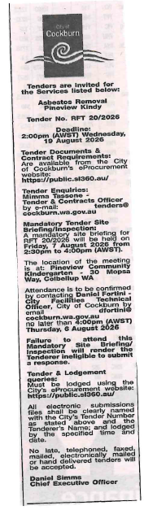 | Director Infrastructure Services  Wednesday, 30 September 2026
 | Date of Council Meeting:
 | Not applicable
Name of Successful Tenderer(s): | Quantum Building Services Pty Ltd t/a Quantum Building Services
Amount of Successful Tender(s): (Ex GST) | $194,269.00

