Tender Title: |  | RFT 24-2020 Bulk Verge Collection & Parks Green Waste Collection
Request ID: |  | 36670
Tender Description: |  | Bulk Verge Collection Contractor Assistance (Ad-Hoc) and Parks Green Waste Collection
Advert Approval: |  | Decision to Advertise: Director of Engineering & Works  Decision Date: Monday, 21 September 2020
Closing Date and Time: |  | 2:00pm (AWST) Thursday, 15 October 2020
Opening Date and Time: |  | 2:00pm (AWST) Thursday, 15 October 2020
 | Tenderer’s Name:
1 | Stefna Family Trust t/a West Tip Waste Control
2 | The Trustee for A W G Family Trust T/AS KRS Contracting t/a KRS Contracting
3 | Western Maze Pty Ltd t/a WA Recycling Service
4
5
6
7
8
9
10

Advertisement
Method 1: City of Cockburn | Method 2: NA
Method 3:  The West Australian – Wednesday, 23rd of September | Tender Awarded by:
Copy of Statewide Notice:  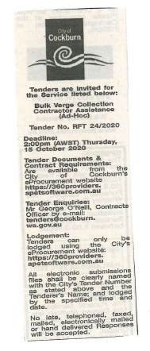 | Director of Engineering & Works  Director of Finance & Corporate Services  Monday, 11 January 2021
 | Date of Council Meeting:
Click here to enter a date. or
Not applicable
Item No:
Name of Successful Tenderer(s): | Stefna Family Trust T/As West Tip Waste Control Pty Ltd
Amount of Successful Tender(s): (ex GST) | $886,950

