**COVID-19 (Coronavirus) Local Recovery Action Plan**

City of Cockburn

Cockburn - Local Response and Recovery Group

Contents

1.0 Executive Summary 3

2.0 Introduction 4

3.0 COVID-19 (Coronavirus) Background 5

4.0 Timeline of COVID Global Events 6

5.0 Purpose 7

6.0 Authority 8

7.0 Local Response and Recovery Group (LRRG) 9

7.1 LRRG Objectives 9

7.2 LRRG Priorities 9

7.3 LRRG Composition 10

8.0 Immediate Relief Initiatives 11

9.0 Implementation Plan 13

9.1 Timing of recovery initiatives 13

9.2 Response Action Plan 15

9.3 Recovery Action Plan 17

10.0 Risk Management 23

11.0 Financial Implications 25

12.0 Recommendations 26

13.0 Bibliography 27

# 1.0 Executive Summary

At the beginning of 2020, the world became aware of an infectious disease (Coronavirus) COVID-19 first identified in Wuhan, China. Since identification COVID-19 has spread across the globe, affecting approximately 185 countries (World Meter 2020) as of March 2020. Western Australia, like the rest of the country, is not immune to the outbreak of COVID-19, with numerous and escalating cases being reported. The Federal Government (of Australia) announced COVID-19 as a national health emergency. The State Government of Western Australia followed suit and declared a State of Emergency in March 2020.

The City of Cockburn has legislative responsibilities under the State’s *Emergency Management Act 2005* to oversee recovery activities during emergency events and health-related prevention and monitoring activities under the other State legislation.

Due to the unfolding pandemic, the City's Local Emergency Management Committee (LEMC) has enacted a Special meeting. This formed the Cockburn Local Recovery Coordination Group (LRRG) as outlined within the City’s Local Emergency Management Arrangements (LEMA).

The Response and Recovery Action Plan (this document) is a guide and plan prepared by the City’s Officers on all likely activities requiring consideration during the Response, Monitoring and Recovery phase of the COVID-19 response. Due to the dynamic nature of the pandemic, this Plan and the activities undertaken by the LRRG over an extended time will be subject to change, and this plan will be amended accordingly.

Unless the situation changes and the Hazard Management Agency (WA Health) or the State Emergency Controller (WA Police Commissioner) provide instruction, the City will oversee the LRRG and its administration, function and structure.

# 2.0 Introduction

The COVID-19 (Coronavirus) Recovery Action Plan was prepared by the City and the Local Response and Recovery Group (LRRG). The Plan intends to guide the Committee’s response to community recovery activities ensuring they are consistent with the State and Federal direction. Recovery activities planned by the LRRG will ensure they are localised to benefit the Cockburn community during the pandemic and recovery phase.

The LRRG will ensure any programmes undertaken are relevant to preventing the spread of COVID-19, minimising economic loses by local businesses and advocating the State and Federal government for resources on an as-needed basis.

The Plan focuses on providing a further detailed 'hands-on' guide to recovery efforts while using the City's existing Recovery Plan within the LEMA as an overarching guide.

As part of further development of this Plan, the City’s Officers will provide a copy of this Plan to the District Emergency Management Committee (DEMC) and the State Emergency Management Secretariat for noting and review.

# 3.0 COVID-19 (Coronavirus) Background

At the time of writing, COVID-19 is being researched by health agencies around the world. Although extensive research is still underway and no cure is available.

*The information below has been provided by the Department of Health (Commonwealth) within their COVID-19 Frequently Asked Questions Factsheet.*

Coronaviruses are a large family of viruses known to cause respiratory infections. These can range from the common cold to more severe diseases such as Severe Acute Respiratory Syndrome (SARS) and Middle East Respiratory Syndrome (MERS). This new coronavirus originated in Hubei Province, China and the disease caused by the virus is named COVID-19.

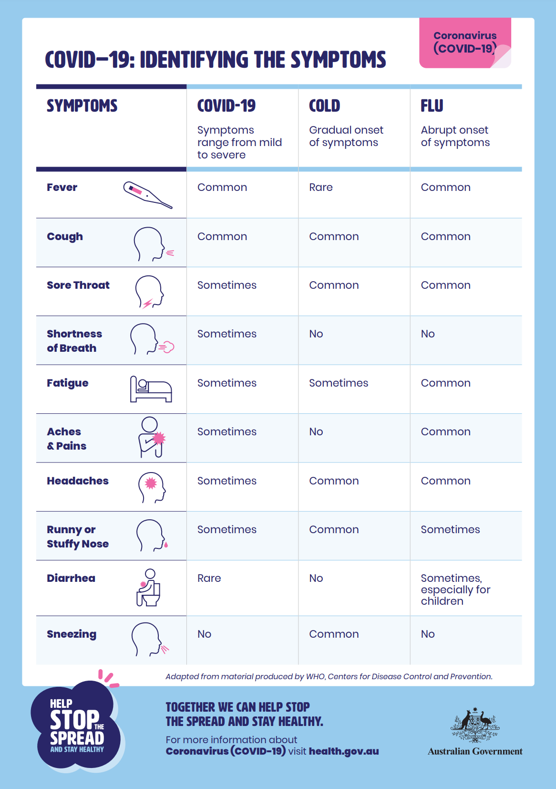COVID-19 is most likely to spread from person-to-person through:

* Close contact with a person while they are infectious or in the 24 hours before their symptoms appeared.
* Close contact with a person with a confirmed infection who coughs or sneezes.

Image 1 Department of Health Information Poster Credit: Department of Health (Commonwealth)

* Touching objects or surfaces (such as door handles or tables) contaminated from a cough or sneeze from a person with a confirmed infection, and then touching your mouth or face.

The symptoms of COVID-19 are similar to other colds and flus and include, fever, sore throat, cough, tiredness and difficulty breathing.

# 4.0 Timeline of COVID Global Events

# 



# 5.0 Purpose

This is an initial plan which will outline the framework and priorities of the City’s recovery from the COVID-19 crisis event.

The intention is for the document to be a “live” document which will be amended and updated as required, depending on how the crisis itself proceeds.

The purpose of the recovery activities is to:

* Assist recovery at a social, built, economic and natural environment level;
* To ensure that the community are supported and potential for those at risk to contract COVID-19 is minimised.
* To ensure that the local economy is positioned to rebound from the impacts of COVID-19 and thrive in the longer term
* To ensure that the community are supported to be sustainable, engaged and connected throughout the duration of the crisis.
* To ensure that the community are kept informed and have a high level of awareness of the City’s activities throughout the crisis during both the response and recovery phases

As the event has evolved in recent times, the most significant impact to communities within Western Australia is likely to be social and economic. Therefore, this Plan will place most of its focus on those two critical dimensions. These recovery focus areas are also aligned with the Local Economy and Community, Lifestyle and Security outcome areas in the City’s Strategic Community Plan 2020-2030.

# 6.0 Authority

The Response and Recovery Action Plan has been established as part of the City’s Recovery efforts pursuant to *s36* of the *Emergency Management Act 2005*. The City’s recovery action will be reviewed and noted by members of the Local Emergency Management Committee and proposed to be adopted as a Sub-plan of its Recovery Plan within the City of Cockburn Local Emergency Management Arrangements.

The City has an arrangement of documents relating to Emergency Management documents as shown (image 1) below.

# 7.0 Local Response and Recovery Group (LRRG)

The LRRG is based on the City of Cockburn Local Emergency Management Arrangements (LEMA) and State Recovery Plan Structure.

The ethos and process is based on the National Principles for Disaster Recovery:

* Understanding the context;
* Recognising complexity;
* Using Community-led approaches;
* Ensuring coordination of all activities
* Employing effective communication; and
* Acknowledgement and building capacity.

7.1 LRRG Objectives

To oversee the coordination of the City’s response and recovery efforts, in particular:

*The aim of the LRRG is to oversee the coordinated process of supporting the Cockburn community in responding to the Covid Crisis, as well as the restoration and accessibility of physical infrastructure, the environment, community, psychosocial, and economic wellbeing.*

7.2 LRRG Priorities

The LRRG will consider the following areas when recommending priorities and ensuring work is completed.

* The City’s Strategic Community Plan 2020-2030;
* The City’s internal and external response measures;
* Health and Safety of individuals and the community;
* Adequately providing for vulnerable people;
* Social recovery;
* Economic recovery;
* Physical recovery; and
* Environmental recovery

7.3 LRRG Composition

The Local Emergency Management Committee reviewed the LRRG composition at its special meeting in March 2020. Upon consultation, the LRRG composition was altered to the structure within the City of Cockburn Local Emergency Management Arrangements and Recovery Plan.

The change in structure allowed the group to be more agile for the anticipated prolonged nature of the pandemic.

The amended structure is shown below.

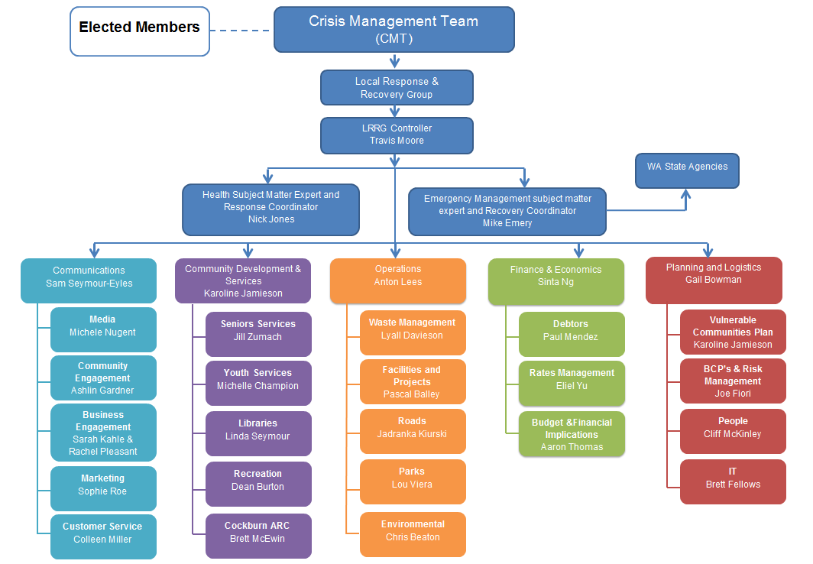

# 8.0 Immediate Relief Initiatives and Vulnerable Community Response

The City acted quickly in responding to the crisis and with immediate effect put the following measures in place to support the community:

* Cancel penalty interest being charged on outstanding rates, effective from 19 March to 30 June 2020 - e*conomic impact: loss of revenue estimated at $75,000 (but only $33,000 below full year budget target).*
* Cancel various rates related fees and charges (ie: direct debit/cheque dishonour fees, refund application fees, payment arrangement fees, copy of rates notice fees) effective from 19 March - *economic impact: loss of revenue estimated at $5,000*
* Suspend formal (legal) debt recovery processes on outstanding rates until 30 June 2020 - *economic impact: delayed cash inflows*
* Ratepayers facing financial hardship will be allowed to defer payments for three (3) months or enter into more generous payment arrangements - *economic impact: delayed cash inflows*.
* Commercial based debtors experiencing financial hardship will be provided with more compassionate payment options - *economic impact: delayed cash inflows*.
* Community based debtors will be allowed to defer repayment of existing debts for three (3) months - *economic impact: delayed cash inflows*.
* Upon request, allow tenants of City owned or managed leased (or licenced) premises to suspend/defer up to 100% of their rent payment (not including outgoings) for an initial 3 month period (to 30 June 2020). Consideration will then be given (at the appropriate time) to any rent relief options, once COVID-19 impacts on tenants and the City are better understood - e*conomic impact: delayed cash inflows (at this stage)*
* Naval Base shack lessees will be afforded more compassionate payment options, with penalty interest being waived to 30 June 2020 - e*conomic impact: delayed cash inflows & loss of penalty interest estimated at under $1,000.*
* Full refunds given on all cancelled bookings and events at City facilities - e*conomic impact: loss of hire and event revenue estimated at under $100,000.*
* Sporting Clubs COVID Support Package - Stage 1 (for seasonal hire clubs up to $750 and leased facility clubs up to $2000). This will support Clubs to continue payment of ongoing costs such as utilities, ESL, insurances etc. thus ensuring that sporting clubs remain financially sustainable during this period where all sources of income have ceased. This will be funded from existing grant programs with available capacity.
* The City has halted the issue of final notices and referrals to Fines Enforcement Registry for already issued infringements until 30 June 2020 - *economic impact: delayed cash inflows*.
* Rangers are taking a more lenient approach with the issue of infringements and issuing cautions where appropriate.
* The City is now paying its suppliers in an average 15 days from invoice (rather than 30 days from end of month) - *economic impact: hastened cash outflows*.
* The City established a Cockburn COVID-19 phone helpline service and phone wellbeing checks for vulnerable people from the 9 April. The helpline assists vulnerable Cockburn residents to plan, identify and be linked and referred to essential services to stay home safely and follow Government and Department of Health advice.
* The City launched a City wide communication campaign between March and April 2020 via multiple channels including letters and emails to all residents to ensure that all residents heard about the Cockburn COVID-19 phone helpline service for vulnerable people (94113319). The communication campaign included key Health Department messages, and information about Cockburn Community Support Services, and financial support measures.
* The City adapted existing community support services to continue to operate for vulnerable community members such as mental health counselling services, financial counselling services, parenting services, seniors services, home help service for the elderly, and child care services.
* The City provided specialist Environmental Health advice to not for profit organisations, individuals and businesses during the pandemic.
* The City established a special Covid-19 grants fund and community development support for not for profit organisations- so that they can support vulnerable people during the pandemic and remain sustainable in the recovery phase.
* The City developed a Cockburn Local Services Directory which included Cockburn Local Government Services, Not For Profit services, Government, and local Business Services which are available during the pandemic.

The website is kept up-to-date with public facing information <https://www.cockburn.wa.gov.au/Home/COVID-19>

# 9.0 Implementation Plan

The implementation phase of the Response and Recovery Action Plan will be coordinated through the LRRG.

At times, the LRRG may interoperate with State, district and community stakeholders to achieve the desired outcomes.

The implementation of response and recovery activities is based on consequence COVID-19 has had on the community of Cockburn.

To assess this risk, the LRRG have used the State Emergency Management Secretariat – Consequence table for the State Risk Project. The LRRG found this was the most suitable matrix to use so that the State could map the level of consequence on an even basis. The LRRG will adjust their consequence tables as required or requested the State Emergency Controller.

Due to economic losses as of March 2020 and the forecast longevity of the pandemic, the LRRG have ruled out any actions plans for the Insignificant and Minor outcomes of the State Emergency Management Secretariat – Consequence table.

9.1 Timing of recovery initiatives

* **Business as Usual** – Ongoing and monitoring initiatives which will be conducted and required for the duration of the recovery period
* **Time bound** – Designated timeframes irrespective of pandemic situation
* **Recovery phases**
* **Early Recovery – 0 – 3 months**

This phase is upon commencement of the relaxation of restrictions following the continual trend of a reduction in active cases. It will be a period hallmarked by a cautious and considered return to normality whereby the community will need to be supported to work through levels of anxiety.

This will see a variety of facilities and businesses allowed to operate with up to 20 people. Community Sport will also return with up to 20 people, however non contact and be administered in accordance with the AIS Framework.

Intrastate borders begin to be relaxed allowing for increased travel within the regions.

During this phase there will likely be a crossover between the response to the pandemic and the beginning of implementing recovery initiatives.

The overall impact on the community and local economy will be unknown at this stage, with key tasks to include impact assessments of both these areas.

* **Mid- term Recovery – 4 – 9 months**

During this phase further restrictions will continue to be eased, with gatherings of up 100 people now permitted. This condition has allowed for the majority of businesses and facilities to begin to open and operate. Community sport is now also at step 3 of the AIS framework which has allowed for a full return to fixtures.

The level of confidence within the community is beginning to increase and return to the “new normal” is now evident.

The City will have a clear understanding around the requirements of both the community and local economy by this stage and will continue to adapt our recovery initiatives to suit the needs.

A large amount of the City’s initiatives are to occur during this phase to allow the smooth transition back to normal life.

* **Long term Recovery – 9 months – 18 months**

By this phase, life has largely returned to the “new normal” with the community and businesses having adapted to a new way of operating and living.

It is envisaged that towards the end of this phase that a vaccine will become available.

State borders have now all been opened permitting travel between the various states, with international borders opened to Countries with similar case levels to Australia.

9.2 Response Action Plan

| What | Why | Who | When | Result | Status |
| --- | --- | --- | --- | --- | --- |
| City Environmental Health Officers respond and monitor people in self-isolation at the request of the WA State Government | As the pandemic unfolds, there may be a need for the City's EHO officers undertake case management of people who are positive to COVID-19 | Manager Environmental Health | As requested by WA Health  Early/ Medium to Long term Recovery | Minimise the spread of COVID-19 within the community and ensuring compliance with State health directions. | Ongoing as required |
| Provide preventative advice to LRRG stakeholders on health matters and update on the Pandemic situation | Ensuring the LRRG minimises its risk to members of spreading COVID-19 and ensuring LRRG programmes are relevant to the current situation | Manager Environmental Health | Ongoing  Early/ Medium to Long term Recovery | Ensures the LRCG recovery programmes are current. | Ongoing as required |
| Develop a Vulnerable Communities Plan (COVID- 19) to initiate aid and support to residents that fall in the vulnerable community category, to be able to access essential services during the response phase. | Estimated 40% of the Cockburn community will fall into the vulnerable category as COVID-19 spreads within the community. | Executive Manager Strategy and Manager, Community Development | March 2020 | Complete an implementation plan to support the vulnerable communities within Cockburn through the use of repurposed City staff. | Development of the Plan completed |
| Establish a phone wellbeing check service with members of the Senior’s Centre and other vulnerable people registered with the City. | To ensure that vulnerable members of the community have a support network and can access essential services. | Manager, Community Development | Ongoing  March Medium to Long term Recovery | Vulnerable members of the Senior’s Centre and other vulnerable people without support feel in-touch with regular contact from staff at the Centre, and other City service areas and can feedback information on recovery efforts undertaken by the LRRG. | Phone call service underway |
| Reporting to the WA Police any breaches of directives which have been issued | Assist in ensuring compliance | Rangers and Community Safety Manager | Ongoing | That the community of Cockburn are compliant with the directives | Ongoing as required |
| Oversee the closure of buildings and gatherings per Federal and State government direction | Ensuring the City's community are undertaking consistent social distancing measures in line with government direction to avoid the additional risk of the community increasing the rate of infection. | Manager Environmental Health/LRRG | On an as-needed basis  Response phase | Minimise the risk of infection to the community. | Completed |
| Oversee the staged reopening of facilities and infrastructure in accordance with the directives issued by the State and as per the agreed LRRG Process | To bring back a level of normality to the community | Manager Environmental Health/LRRG | On an as-needed basis  Response phase | Community returns to normality |  |
| A zero percentage average increase to rates | Improving cash flow/reducing expenses for local households and businesses | Manager Financial Services | 2020/21 | More money in residents pockets stimulates local economy | To be considered as part of the Annual Budget Deliberation Process |
| The City of Cockburn will promote all City initiatives as related to the response to COVID-19 | It is critical that information is communicated to the correct stakeholders (internal and external) in a timely manner | Manager Corporate Communications | Ongoing  Early/ Medium to Long term Recovery | The relevant stakeholders know what they need to know. | Ongoing |
| Develop a reopening requirements list outlining signage strategy, ppe and hygiene/cleaning requirements which is consistent with State guidelines | Ensures a level of preparedness come the time that facilities are required to reopen | Manager Environmental Health and  Manager Corporate Communications | Ongoing response | Ensuring that facilities can reopen | Process underway, with all facilities developing a detailed list of requirements and required timelines for opening |

9.3 Recovery Action Plan

| What | | Why | Who | | When | Result | Budget Implications | Status |
| --- | --- | --- | --- | --- | --- | --- | --- | --- |
| Health Recovery – To ensure that the community is supported and potential for those at risk to contract COVID 19 is minimised. | | | | | | | | |
| Develop services which will assist in reducing the number of people who have one or more lifestyle diseases/conditions that makes them vulnerable to becoming very sick if infected by COVID 19. | | To ensure those that are most susceptible are supported | Manager of Environmental Health | | Ongoing  Early/ Medium to Long term Recovery | Those who have lifestyle diseases/conditions will be less susceptible to COVID 19. | TBC |  |
| Social/Community Recovery – To ensure that the community is supported to be sustainable, engaged and connected to return to the “new normal” | | | | | | | | |
| Complete a gap analysis of needs and requirements for the community i.e. resident associations, community groups, not for profits | | Provide a detailed understanding of concerns, issues and gaps for support initiatives within the community | Manager Community Development/Coordinator Community Development | | May – June 2020 | Increased understanding of recovery activities needed by the community | Minimal |  |
| Local specific Business Advisor to support not for profit groups to plan i.e. accounting, marketing | | To ensure that the not for profits and sporting clubs are appropriately prepared to navigate their way through the crisis | Community Development Coordinator and Club Development Officer | | Ongoing  Early/ Medium to Long term Recovery | Ensure that not for profit groups are supported and structured to be sustainable through the pandemic | Minimal |  |
| Provision of ongoing modified services for those that have to remain in their homes and are considered vulnerable members of the community | | Ensure the health and wellbeing of the community is maintained | Manager Community Development | | Ongoing  Early - mid Recovery | The community’s wellbeing is not compromised by their inability to attend facilities and programs | TBC |  |
| Develop a sporting club relief fund Stage Two to provide financial assistance to clubs for ongoing costs | | To ensure clubs long term sustainability through the crisis | Manager Recreation and Community Safety | | April 2020 | Clubs are able to commence operation as soon as they are permitted to | $100k (not budgeted) |  |
| Provision of online home work out programs created by ARC team | | To ensure the community can stay active during the crisis | Cockburn ARC Manager | | April 2020 | People remain fit and healthy | $2k | Online programs one the web and available to the public |
| Administer City Reference Groups through online web conferencing platform | | To ensure the continued function and engagement of key interest areas | Reference Group Responsible Officers | | Early Recovery | To ensure that lines of communication and engagement with Councils community reference groups remains open | Nil |  |
| Review the following grants and funding programmes and consider increasing to assist in Covid recovery:   * Welfare Grants * Seniors Security Subsidy * Creation of specific COVID fund | | To ensure adequate opportunities to support the community through the provision of grants, funding and sponsorship | Manager Community Development and Rangers and Community Safety Manager | | Mid recovery | To provide a variety of opportunities for grants and funding that ensure adequate community support during the crisis | TBC | To be considered by Council |
| Youth Services will redirect services to areas identified as high risk or increased need due to the impacts of COVID-19. Youth Services will also increase focus on providing Youth Employment Support and supporting Employ Local strategies | | To Support more vulnerable groups and individuals experiencing greater impacts from COVID-19 to recover. | Youth Services Manager/ Youth Centre Coordinator/ Youth Development Officer | | Early recovery and on-going while required | Reduce negative impacts on more vulnerable individuals and support and increase employment skills and opportunities for young people | Nil. |  |
| Develop services and modify practices to support seniors in Cockburn with high vulnerability or an on-going requirement to self-isolate during the recovery phase. This may include facilitating the provision of sessions and groups remotely, online or telephone activities and provision of regular phone wellbeing checks. | | To reduce risk of infection in groups with higher vulnerability by supporting them to stay at home for an extended period through provision of remote person to person contact and connection to others, improving mental health and decreasing social isolation. | Childcare and Seniors Manager/ Cockburn Care Manager/ Seniors Centre Co-ordinator | | Early recovery and on-going while required | Risk of infection in groups with higher vulnerability reduced, contact and connection to others maintained, mental health improved and social isolation reduced | Nil. |  |
| Economic Recovery – To ensure the local economy if positioned to quickly rebound from the impact from COVID-19 and thrive in the longer term. | | | | | | |  |  |
| Complete COVID 19 scenario planning workshop with Farlane | | Develop clear and concise actions which are aligned to the Strategic Community Plan | Business Engagement Officer/Manager Strategic Planning | | April 2020 | Understand the current impacts of local businesses that can guide the development of further recovery activities | $10k | Session held with various internal stakeholders, |
| Undertake business impact survey of local businesses | | To gain a better understanding of the overall impact on the local economy caused by COVID 19 to inform the City’s actions.  Opportunity to share information to support business to start back up.  Gathering data on businesses for the development of the database` | Business Engagement Officer | | May 2020 | Understanding to the impacts to the local economy to |  |  |
| Waive fees for all Ministerial Exemptions from Planning Requirements during State of Emergency & Charge a capped nominal fee of $50 for any COVID-19 “Temporary Use” applications or $0 in case of hardship. | | To allow businesses to be agile and flexible during the crisis | Manager Statutory Planning | | April 2020 – 1 May 2023 (end date as per Ministerial Notice of Exemption) | Businesses are able to change and adapt their services to mitigate the impact of the pandemic. | $300k | Underway |
| Expand the businesses currently included on the business register | | To provide details of a wider range of local businesses to the community | Business Engagement Officer | | April/May 2020 | More businesses are captured on the register providing them with increased exposure and providing the community with a greater level of information about the services which local businesses provide. | $5k | In Progress |
| Implementation/expansion of Buy Local Policy for internal purchases | | To improve rate of local spending by the City | Procurement/ Business Engagement Officer | | April/May 2020 | More money spent in local area, stimulation of local economy | Minimal | In progress |
| Removal of the mandatory waste service levy from those commercial/ industrial properties not using the City’s waste service | | To reduce operational expenses for local businesses for a service they are not utilising | Waste Services/Business Engagement Officer | | July 2020 | Decreased rates notices for businesses | $500k | Approved - implemented as of 1 July 2020 |
| Consider opportunities to bring forward Capital Works program | | Stimulate local economy, provide employment | Finance | | 2020 onwards | The ability to leverage Council Municipal funding with external funding and assist in stimulating the economy | TBC | Underway |
| Provide a COVID-19 social distancing and hygiene package targeted at assisting businesses | | To reduce costs for local businesses and show City support for small business community via branding | Business Engagement Officer | | Early Recovery | Increased CoC visibility in community & shop local & business support messaging | $2k | In progress |
| Build skills to support shifting to new Business models /opportunities via skill development workshops | | To remain viable and competitive in the changing business landscape, enterprises may need to pivot their capabilities to new business practices and markets. | Business Engagement Officer | | Early/Mid recovery | Businesses have capability and capacity to thrive in new economic environment | Minimal due to existing sponsorship arrangements with MCCC and Business Foundations | Not yet commenced |
| Work with industry, SWG and others to advocate, and grow/connect what is already there through clustering. | | To remain viable and competitive in the changing business landscape, enterprises may need to capitalise on economies of scale and skill sharing across industries | Business Engagement Officer – with SWG MCCC & Henderson Alliance | | Ongoing | Develop synergies in business community | Minimal | In progress |
| Work with Curtin University Ignition program to support City of Cockburn Start Ups | | Create new opportunities for start-ups in Cockburn and foster innovation | Business Engagement Officer | | Mid recovery | Sponsorship of 2 businesses in Ignition Program for 2020 | $6500 (from Grants & Donations Budget) |  |
| Development of Business Grants Program to help businesses adapt to new conditions and opportunities | | To remain viable and competitive in the changing business landscape, enterprises may need to pivot their capabilities to new business practices and markets. | Business Engagement Officer | | Early recovery | Businesses have capability to thrive in new economic environment, provide businesses with the support required to enact changes in an efficient and effective manner. | $100k (not budgeted for) |  |
| Work with the community, innovators and industry to explore development of innovation and co-working hubs across the City of Cockburn | | Recognition that there are under-utilised assets within the control and/ or influence of the City. | Business Engagement Officer | | Long Term recovery | Maximise capability of home based workforce, utilisation of community facilities & resources | $100k (not budgeted for) |  |
| Identify the City’s availability of resources and facilities to assist both businesses and workforce working from home | | Support to facilitate the “new normal” working environment | Business Engagement Officer and Coordinator Recreation Services, Property and Lands Officer and Manager Libraries | | Mid recovery | Maximise capability of home based workforce, utilisation of community facilities & resources | Minimal |  |
| Utilise the City’s GIS and data capabilities to create a directory platform that connects businesses with other businesses, workforce and community. This can be used to identify:  − Supply chain synergies  − Employment opportunities  − Industry cluster  − Zoning  − Infrastructure utilization | | Opportunities for collaboration and alignment between City business units need to be identified and realised to optimise economic development impacts for City workers, households, firms, places, industries and clusters. | Business Engagement Officer and GIS Coordinator | | Mid recovery | Businesses have capability to thrive in new economic environment, provide businesses with the support required to enact changes in an efficient and effective manner. | $50k (not budgeted for) | In progress |
| Public Information – To ensure that the community are kept informed and have a high level of awareness of the City’s activities throughout the crisis during both the response and recovery phases | | | | | | | | |
| Service providers will develop and create communications to sustain a sense of community during periods of isolation. | Research has shown that people who feel isolated have higher chances of mental health issues such as depression and also increased alcohol, and drug use. | | City of Cockburn service providers including but not limited to Libraries, Seniors Centre, ARC, Youth Services, Child Care Services, Cockburn Care | Ongoing  Early Recovery | | Media content to maintain a sense of community to those who are affected by self-isolation. The campaign will assist to maintain community spirit. | Minimal | Ongoing |
| Promotion of community initiatives, programmes and services not affected by self-isolation. | Ensure the community awareness of programmes is maintained to improve the perception of services and possible activities that can be undertaken by the City. | | Manager Corporate Communications | Ongoing  Medium-term Recovery | | Assist stem any mental health issues arising from self –solation and fears of social disorder from a long pandemic. | Current | Ongoing |
| Promote the formation of the Local Response and Recovery Coordination Group to City staff, Elected Members, community and stakeholders and resulting activities | Bring about awareness within the community of recovery actions being undertaken by the LRRG with the hope of reducing uncertainty. | | Manager Corporate Communications /Business Engagement Officer –City of Cockburn  And  LRRG members | Ongoing | | Increased understanding of recovery activities by the community leading to a reduction of fear and uncertainty. | Current | Ongoing |

# 10.0 Risk Management

The Following risk management have been considered by the LRRG. The matrix uses the City’s Risk Management framework, based on the ISO 3100:2009 principles.

|  | Risk | Consequence | Likelihood | Risk Rating | Mitigation controls |
| --- | --- | --- | --- | --- | --- |
| 1.1 | LRRG not adhering to State norms or direction by the State Emergency Controller | Critical | Unlikely | Moderate | The LRRG structure is aligned to the City’s LEMA, which has been reviewed by the SEMC. Members of the LEMC include the Emergency Management District Advisor to mitigate this risk.  The City's Recovery Coordinator is also attuned the roles and responsibilities of the EM Act to mitigate this risk further. |
| 1.2 | LRRG activities fail due to lack of coordination by the LRRG | Critical | Possible | Substantial | The Implementation phase has been workshopped with numerous key stakeholders to ensure it meets the community needs. The Implementation part of this plan is fluid and will change as and when required.  Maintaining key relationships with agencies, such as WALGA, will further mitigate this risk by ensuring the LRRG have contemporary information available. |
| 1.3 | Public backlash on the LRRG activities or perceived effectiveness | Major | Possible | Moderate | Ensuring there is effective two way and transparent communication is a key element of the LRRG with the community.  Providing the ability for the community to provide feedback on LRRG programmes with further minimise this risk. |
| 1.4 | LRRG unable to perform functions due to restrictions on meetings and groupings | Critical | Likely | High | All LRRG will be securely broadcasted to members through the use of videoconferencing facilities. The use of technology will help minimise contact between members and ensure meetings and workshops can continue as planned, especially when most will be working from home. |
| 1.5 | LRRG fail to gain the support of the City Executive or Elected Members | Catastrophic | Unlikely | Substantial | THE LRRG has initial support from the Executive and the City's Elected Members. This support will be monitored, and updates on the LRRG successes and failings will be provided to the Executive and Elected Members on a regular basis. |

# 11.0 Financial Implications

The Local Response and Recovery Plan is estimated to have an overall financial impact of approximately $5M.

This amount is made up of a mixture of lost revenue and additional expenses related directly to the COVID-19 initiatives and has largely already been factored into 2019/20 EOFY projections and the 2020/21 budget. The Local Response and Recovery Plan resourcing requirements will be included in the new Corporate Business Plan 2020-2024.

In addition to the direct costs associated with the initiatives outlined in the implementation plan, it is recommended that a further $50k be allocated to resourcing of the plan in the form of casuals and various consultants. This brings the total amount of unbudgeted costs to $400k.

In addition to the known costs, there are also a number of initiatives such as bringing forward of capital works projects to obtain Federal and State COVID-19 funding which at this stage are unknown.

The LRRG will investigate external funding opportunities as they become available

# 12.0 Recommendations

1. That Council endorses the Local Response and Recovery Plan
2. Notes that the actions included in the Response and Recovery Plan are still subject to Council’s annual budget deliberation process
3. Notes that the Plan will be reviewed on a biannual basis until such time as the recovery phase of the crisis has been completed
4. Investigates further opportunities to leverage state and federal funding to complement municipal fund contributions

# 13.0 Bibliography

Community Recovery, Australian Institute of Disaster. *Handbook 2 - Community Recovery.* East Melbourne: The Australian Institute for Disaster Resilience, 2018.

Red Cross, New Zealand Red. *recovery matters.* New Zealand Red Cross, unkown.

World Meter. *World Meter.* March 2020. https://www.worldometers.info/coronavirus/#countries (accessed 21 March, 2020).

**Contact Us**

**City of Cockburn**

9 Coleville Crescent, Spearwood WA 6193

PO Box 1215, Bibra Lake DC Western Australia 6965

Telephone: 08 9411 3444 Fax: 08 9411 3333

Email: [customer@cockburn.wa.gov.au](mailto:customer@cockburn.wa.gov.au)

[City of Cockburn website: cockburn.gov.wa.au](http://www.cockburn.gov.wa.au)

Socila media logos: Facebook, Twitter, Instagram and YouTube.