19 July 2023

**Cockburn business recipients of City’s 2023 Local Economic Development Grants to share in $101,145**

A physio who offers a bike fitting service, a dance school providing dance therapy for mental health, and a manufacturer of fishing accessories are among recipients in the 2023 round of the City of Cockburn’s Local Economic Development Grants (LEDG).   
   
The City received 40 grant applications during April and May and 29 recipients received an average of $3,487, sharing a total of $101,145 between them.

This is the third round of LEDG grants. Previous rounds delivered $85,000 to 20 businesses in June 2021 while 27 grants totaling $99,500 were provided in 2022.      
   
Grants of up to $5,000 are targeted at micro, small and medium size businesses with 1-99 employees based in the City of Cockburn or with services directly benefitting the Cockburn community.   
   
The grants can be used to help establish new enterprises, improve digital capabilities and support innovation and training in the post pandemic recovery.   
   
City of Cockburn Economic Development Manager Michael Faulkner said the total value of projects supported in the current round was $250,000, which generated income for other local and regional service providers, further stimulating the local economy.   
   
“Businesses used their grants to upskill staff, improve their cyber security, set-up specialist playgroups, launch new therapeutic goods, and establish digital marketing, e-commerce capabilities and websites,” Mr Faulkner said.   
   
“It is heartening to see the diversity of the local small business community which is busy innovating and diversifying to deal with the rising costs of living.   
   
“The City understands the pressures on business owners and is focused on supporting a diverse local economy with programs, scholarships and training opportunities.”

More than 9,297 business call Cockburn home, many of whom are small and micro businesses. The City has developed initiatives like the Micro Business Networking group targeted to support these emerging enterprises to grow and thrive.

The grants are one way we provide financial support, along with scholarships and sponsorships for business owners to attend training and development.

Mr Faulkner said the strong uptake of this year’s grants demonstrated their value to the local business community.

“The high quality of applications this year showed how many worthy Cockburn businesses applied in what was a highly competitive round,” he said.    
   
The grants are part of the City’s grants, donations and sponsorship Cockburn Community Fund, which distributes more than $1.4m to the community annually.   
   
Another round of grants will be offered in early 2024. To find out more, visit the City’s [**website**](https://www.cockburn.wa.gov.au/Community-and-Business/Business-Support/Grants-for-businesses?viewmode=0).

2023 grant recipients:

* Miss Nat’s Dance School – $2,985 Dance therapy
* Fam-ally – $4,146 Mobile sensory gym
* Made to be Free – $5,000 Photography & marketing
* Connect Learning After School PTY LTD – $2,000 Website development
* Glitterati Performance Company – $3,000 Website & Search Engine Optimisation
* Perth Psychologist ­– $3,000 Website design & upgrade
* Whitney Consulting – $3,000 Cyber security enhancement
* Baked Thingz – $3,000 E-commerce website development
* Caroline’s Skincare – $5,000 Product manufacturing & launch
* Rockstar Brownies – $2,727 Website development
* Suzette Collective – $2,700 Website design & development
* Cosy Crab Laundrette – $5,000 Shopfront renovation
* Green Pea Toys – $3,140 Product manufacturing
* The Organic Collective – $3,000 IT modernisation
* Adventure Physio – $4,365 Service set up
* Co.Fit Studio – $3,000 Internal software upgrade
* Cooby CoWork – $5,000 Community Garden & signage development
* Tirohanga Counselling Services – $3,000 Website development
* Karri Penley – $3,000 Digital marketing & website development
* Top One Hong Kong BBQ House – $1,450 Window dressing
* Digital Jellyfish – $5,000 Business plan development
* Disability Support Management – $2,925 Website accessibility enhancement
* Peach Speech Pathology – $5,000 Street front Improvement
* Coolbellup Newsagency – $4,500 Shop sign refresh
* NursePrac Australia – $3,000 Technology enhancement
* Happy Chopstix Vietnamese Café – $4,950 Shopfront development
* Digital Marketing Ninja – $1,500 Hardware upgrade
* Dale and Waters – $3,000 Website upgrade development
* Rig Mate – $3,756 Trade show exhibit

**Caption:** Steph Lock from Adventure Physio in Bibra Lake will use her grant to provide clients with a bike fitting service, to help prevent and treat cycling injuries.

ENDS

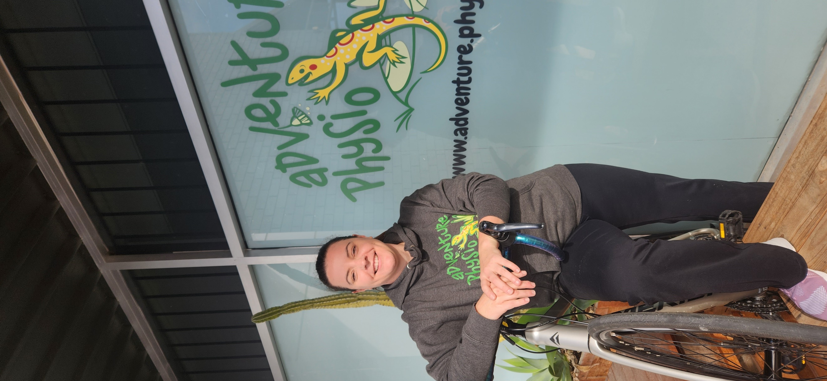

For more information contact:  
Media and Communications Officer  
City of Cockburn  
T: 08 9411 3551  
E: media@cockburn.wa.gov.au