Tender Title: |  | RFT08/2025 – One (1) Passenger Bus
Request ID: |  | 55382
Tender Description: |  | The City of Cockburn (the Principal) requires the supply and delivery of one (1) Passenger bus with a minimum of 43 seats. The bus will require access suitable for Seniors who may have mobility impairments and comfortable seating for seniors. The bus is to have the flexibility to enable storage of mobility aids such as walking frames. The bus will primarily be used for the transportation of Seniors Centre Members on outings.
Advert Approval: |  | Decision to Advertise: Director, Infrastructure Services  Decision Date: Tuesday, 4 March 2025
Closing Date and Time: |  | 2:00PM (AWST) Thursday, 20 March 2025
Opening Date and Time: |  | 2:00PM (AWST) Thursday, 20 March 2025
 | Tenderer’s Name:
1 | Yutong Bus Centre WA (Perth Office)
2 | BCI SALES PTY LTD t/a BCI (BCI Sales WA)
3
4
5
6
7
8
9
10

Advertisement
Method 1: City of Cockburn | Method 2: Yammer
Method 3:  The Western Australian, Wednesday, 5 March 2025 | Tender Awarded by:
Copy of Statewide Notice:  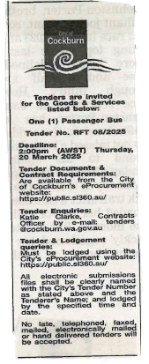 | Director, Infrastructure Services  Wednesday, 21 May 2025
 | Date of Council Meeting:
 | N/A
Name of Successful Tenderer(s): | WA Bus and EV Solutions Pty Ltd t/as Yutong Bus Centre WA
Amount of Successful Tender(s): (ex GST) | $293,190.00

