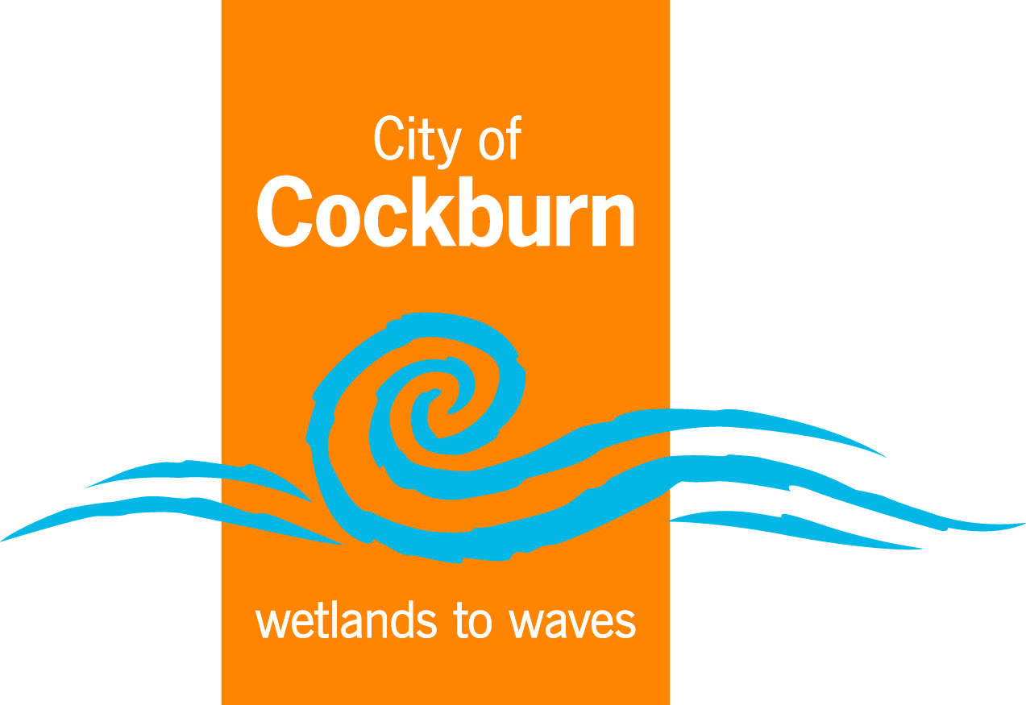

Transcript
Introduction to Web Accessibility and W3C Standards

Hi! My name is Shadi Abou-Zahra.
I'm the Accessibility Strategy and Technology Specialist at W3C, the World Wide Web Consortium, and today I'd like to tell you about web accessibility.

The Web is for many people an essential part of daily life. At work, at home,
and on the road. Web accessibility means that people with disabilities can use the Web equally.

For example, somebody who cannot use their arms, and uses a mouth stick to type.
Or someone who cannot hear well, and uses captions to watch videos.
Or someone who cannot see well, and uses a screen reader to read aloud what's on the screen.

Accessibility has many benefits. For example, captions benefit anyone in a loud or in a quiet environment. And good colour contrast works better when there is glare.
Also people with age-related impairments, such as reduced dexterity, benefit.

In fact, everyone has a better user experience with an improved layout and design.
A lot of accessibility can be built into the underlying code of websites and applications.

Web technologies from W3C, such as HTML, provide support for many accessibility features.

For example, features to provide text alternatives for images, which are read aloud by screen readers and also used by search engines. Also headings, labels, and other code supports accessibility and improves the quality overall.

Good authoring tools, such as wikis, content management systems, and code editors, help create accessible code, either automatically or with input from the author.

Also web browsers, media players, and apps need to support accessibility features.
W3C provides standards to help make the Web accessible, which are internationally recognized by governments and businesses. Most well-known is the Web Content Accessibility Guidelines - WCAG.

WCAG is also the ISO standard 40500, and adopted in the European standard called EN 301 549. It is built around four core principles:

First Perceivable - for example, so people can see the content, or hear it.
Operable - for example, so people can use the computer by typing, or by voice.
Understandable - for example, so people get clear and simple language.
And Robust - so people can use different assistive technologies.
Besides WCAG, W3C also provides the Authoring Tool Accessibility Guidelines - ATAG, which defines requirements for content management systems, code editors and other software. And the User Agent Accessibility Guidelines - UAAG,
defines requirements for web browsers and media players.

There are over one billion people with disabilities, or about 15-20% of the population.
The UN Convention on the Rights of Persons with Disabilities defines that access to information, including the Web, as a human right.

Most countries around the world have ratified this UN convention, and several have adopted binding policies too.

Yet regardless of any laws and regulations, implementing the accessibility standards is essential for people with disabilities, and useful for all.

For more information on web accessibility, visit w3.org/WAI

