Tender Title: |  | RFT 26/2024 – SUPPLY OF STOCK LIBRARY ITEMS – CITY OF COCKBURN LIBRARIES - Three (3) Year Contract
Request ID: |  | 55039
Tender Description: |  | The City of Cockburn is seeking a suitably qualified and experienced contractor for the supply, delivery, cataloguing and processing of local stock library items for the City of Cockburn Libraries. The Contractor is required to provide library items to all libraries within the City of Cockburn.
Advert Approval: |  | Decision to Advertise: Director Infrastructure Services  Decision Date: Thursday, 24 October 2024
Closing Date and Time: |  | 2:00PM (AWST) Thursday, 14 November 2024
Opening Date and Time: |  | 2:00PM (AWST) Thursday, 14 November 2024
 | Tenderer’s Name:
1 | Bolinda Publishing Pty Ltd t/as Bolinda Publishing Pty Ltd
2 | James Bennett Library Services
3 | J.D Caffey & Caffey Family Trust t/as Westbooks
4
5
6
7
8
9
10
11

Advertisement
Method 1: City of Cockburn | Method 2: Yammer
Method 3:  The Western Australian, Wednesday 30th October 2024 | Tender Awarded by:
Copy of Statewide Notice:  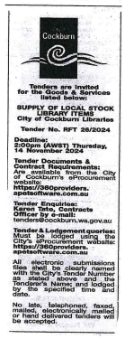 | Anton Lees, Director Infrastructure Services  30th October 2024
 | Date of Council Meeting:
 | N/A
Name of Successful Tenderer(s): | J.D Caffey & Caffey Family Trust t/as Westbooks
Amount of Successful Tender(s): (ex GST) | $216,540.00 (Excl Gst) Estimated Contract Sum

